Dolgorsüren and family milking cows and making aaruul
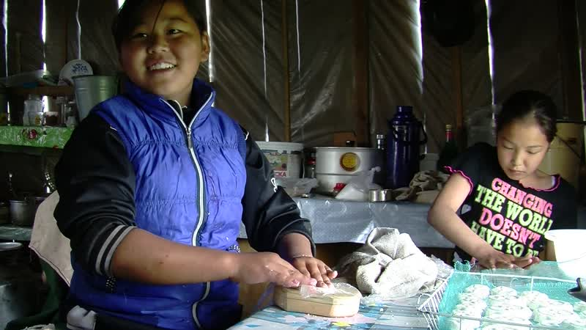

identifier
4a64370b-a4a8-4098-aab9-a234a148f2e1

creator
Thrift, Eric

type
Moving Image

coverage
Mongolia
Selenge aimag
Yeröö sum

description
The recordings in this series depict Dolgorsüren and her grandchildren milking cattle and making aaruul. The family makes two types of aaruul, using molds and a homemade extruder (producing khorkhoi aaruul), out of curds mixed with chokecherries and with drink syrup flavourings.

publisher

source

rights

subject
Pastoralism Videos
Milking Cattle
Making Aaruul
Dologorsuren

date
2012-07-23

language

format
inode/directory

modified
2018-03-02 09:37:44

original filename
PastoralismVideos--2012-07-23--MilkingCattle--MakingAaruul--Dologorsuren--Selenge-Yeroo.vclips

table of contents
time | clip | description
0:00:00 | 300G0058 01 | Dolgorsüren and her grandchildren Uuganbayar and Urangoo (two cousins) milk the cows.
0:13:53 | 300G0058 02 | Dolgorsüren and her grandchildren (two cousins) milk the cows (continued).
0:27:47 | 300G0058 03 | Dolgorsüren and her grandchildren (two cousins) milk the cows (continued).
0:41:40 | 300G0058 04 | Dolgorsüren and her grandchildren (two cousins) milk the cows (continued).
0:55:34 | 300G0058 05 | Dolgorsüren and her grandchildren (two cousins) milk the cows (continued).
0:56:55 | 300G0059 01 | Urangoo kneads curds mixed with sugar. She shows the different molds used in Dolgorsüren's household. Uuganbayar takes out a bucket of whey to feed the small livestock. Urangoo begins pressing the curds into the molds, placing them on a wire rack. Dolgorsüren looks for her hat to wear in making an offering (*tsatsal orgokh*), and not finding it, jokingly puts on the baby's hat. She goes out and makes the offering to the mountains.
1:10:48 | 300G0059 02 | Dolgorsüren churns the airag. Urangoo continues molding aaruul. After a few minutes Dolgorsüren comes over with a sack of pressed curds. She takes the curds out of the sack and begins cutting them with a string.
1:24:42 | 300G0059 03 | Urangoo and Dolgorsüren continue to make aaruul. Narangarav (visiting from the city) gives it a try along with her daughter and sister. Urangoo and Naranjargal mold curds.
1:38:36 | 300G0059 04 | Urangoo and Naranjargal mold curds. Urangoo stirs the milk on the stove for several minutes, then takes the pot outside and places it on the ground to cool. She returns indoors and covers the stove. She takes a tray of aaruul and places it on the roof of the house to dry. Dolgorsüren mixes powdered drink mix in with curds for making flavoured khorkhoi aaruul.
1:52:30 | 300G0059 05 | Dolgorsüren, Urangoo, and Naranjargal continue making khorkhoi aaruul. Uuganbayar comes in and begins pressing the aaruul through an extruder made from a tin can with holes punched in the end.
2:00:07 | 300G0059 06 | Dolgorsüren, Urangoo, and Naranjargal continue making aaruul.
2:14:01 | 300G0059 07 | Dolgorsüren, Urangoo, and Naranjargal continue making khorkhoi aaruul. Dolgorsüren mixes more curds (aarts) with sugar. The group make striped aaruul using a combination of flavoured and unflavoured curds. Naranjargal and Urangoo take the aaruul to the house to set it out to dry.
2:27:55 | 300G0059 08 | Naranjargal and Urangoo set out the trays of aaruul on the roof of the house.They walk back through the garden and to the summer house (ambaar). They resume molding aaruul.
2:41:49 | 300G0059 09 | Naranjargal and Urangoo continue molding aaruul.
2:55:43 | 300G0059 10 | Dolgorsüren holds her niece's daughter. Naranjargal and Urangoo continue molding aaruul.
3:09:36 | 300G0059 11 | Urangoo molding aaruul.

