“Marx Went Away” book cover
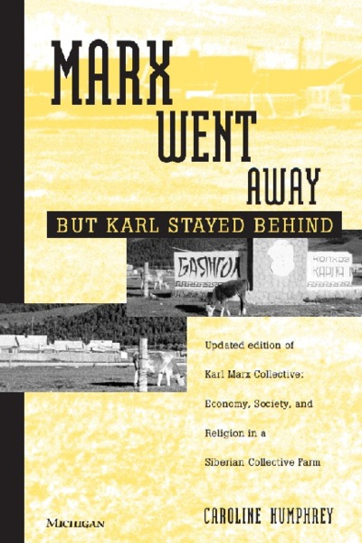

identifier
4f283520-68c0-43cb-8f45-6443b054c9e8

creator
Humphrey, Caroline

type
Text

coverage
USSR
Buryatia

description

publisher

source
Karl Marx Collective

rights

subject

date

language

extent
36.7MiB

contributor

original filename
Marx-went-away.pdf

relation

format
application/pdf

