9409
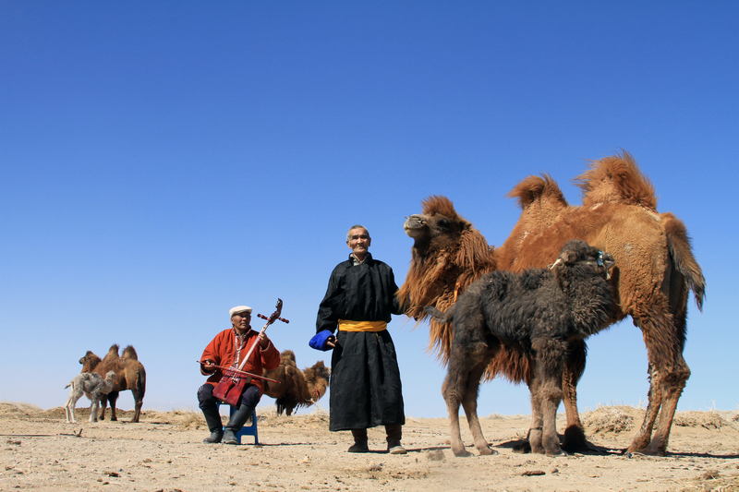

identifier
504ccf76-fbfd-4489-ac5e-325bc2b970d8

creator
Boldbaatar, Yu.

type
Image

coverage
Mongolia
Ömnögovi aimag
Khankhongor sum

description
The mare-camel is accepting the orphan calf - 2 (Khankhongor Sooum, Umnugobi Province)

publisher

source
https://ich.unesco.org/img/photo/src/09409.jpg

rights

subject

date
2011

language

original filename
09409.jpg

extent
9.1 MiB
5184x3456 px

format
image/jpeg

modified
2016-02-24 14:46:35

