Motorcycle at camel race
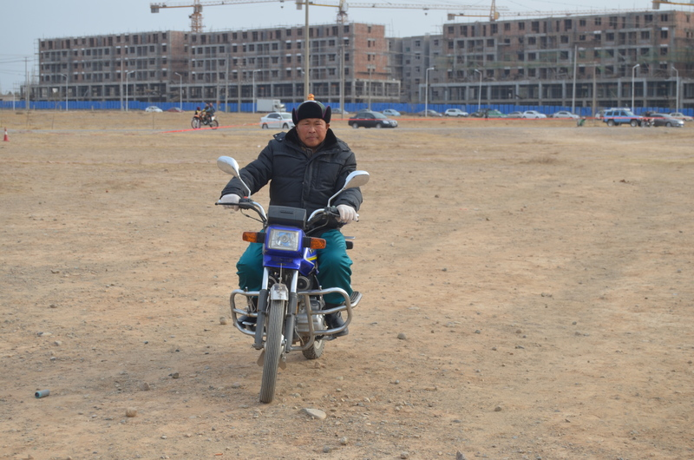

identifier
51e91b73-d22d-443b-ae70-09a683a95e9c

creator
White, Thomas

type
Image

coverage
Alashan
Inner Mongolia
PRC

description
Herder on motorcycle at a camel race. In the background is a new apartment complex being constructed, which will become home to pastoralists who have moved off the land.

publisher

source
Image submitted by the author.

rights
Copyright Thomas White. All rights reserved. Please contact the author for information on re-use.

subject
camels

date
2013-11-10 08:49:38

language

format
image/jpeg

contributor

original filename
DSC_0341.JPG

relation

extent
4.1MiB
4928x3264 px

