Дэлхийгээс зайл - Za shuurhai medee haluunaaraa. Bidnii...
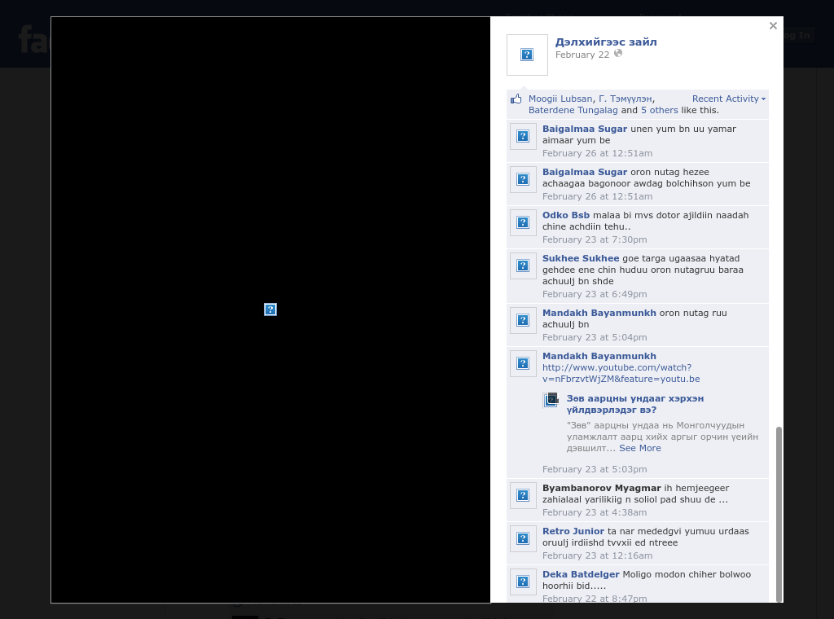

identifier
521480d0-ed92-4736-a9cd-f0a6c7925e6b

creator

type
Text

coverage
Mongolia

description

publisher

source
https://www.facebook.com/DelhijgeesZail/photos/pcb.433907273409096/433907220075768/?type=1&amp;theater

rights

subject
Mongolia
dairy
nationalism
social media

date
18 Mar 2014 11:55:02

language
Mongolian

format
text/plain

modified
2018-01-11 14:12:43

original filename
facebook.com.Delhiigees_zail.url

extent
75.0 B

