Photographs from Barguzin, No. 04
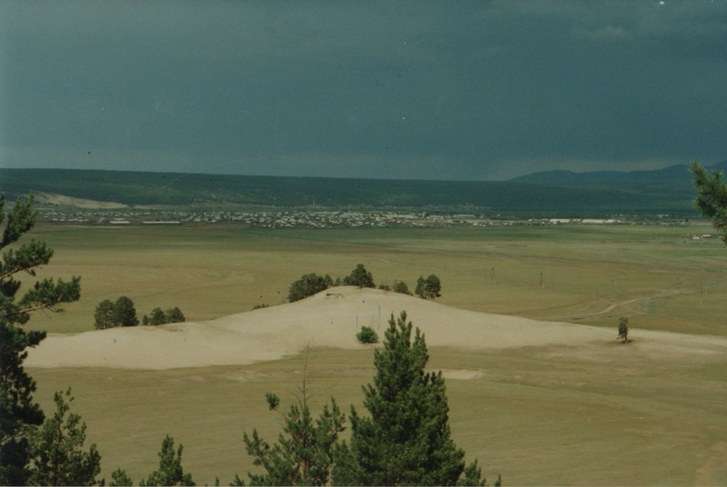

identifier
52df1490-9be1-46bc-aefd-075392b6e214

creator
Gomboev, Bair

type
Image

coverage
Barguzin
Burtyatia
Russian Federation

description
General view of Argada village; poor pastures close to the village.

date
1993-07

language

format
image/png

modified
2017-05-25 01:58:52

original filename
bair-batbuyan-photos-04.png

source
Scanned from a photographic print held in the archives of the Mongolia and Inner Asia Studies Unit, University of Cambridge

extent
3.2 MiB
1777x1191 px

subject
pastoral camps
rangeland

