Oral history interview No. 081218B with Davaasambuu (b. 1958): translation
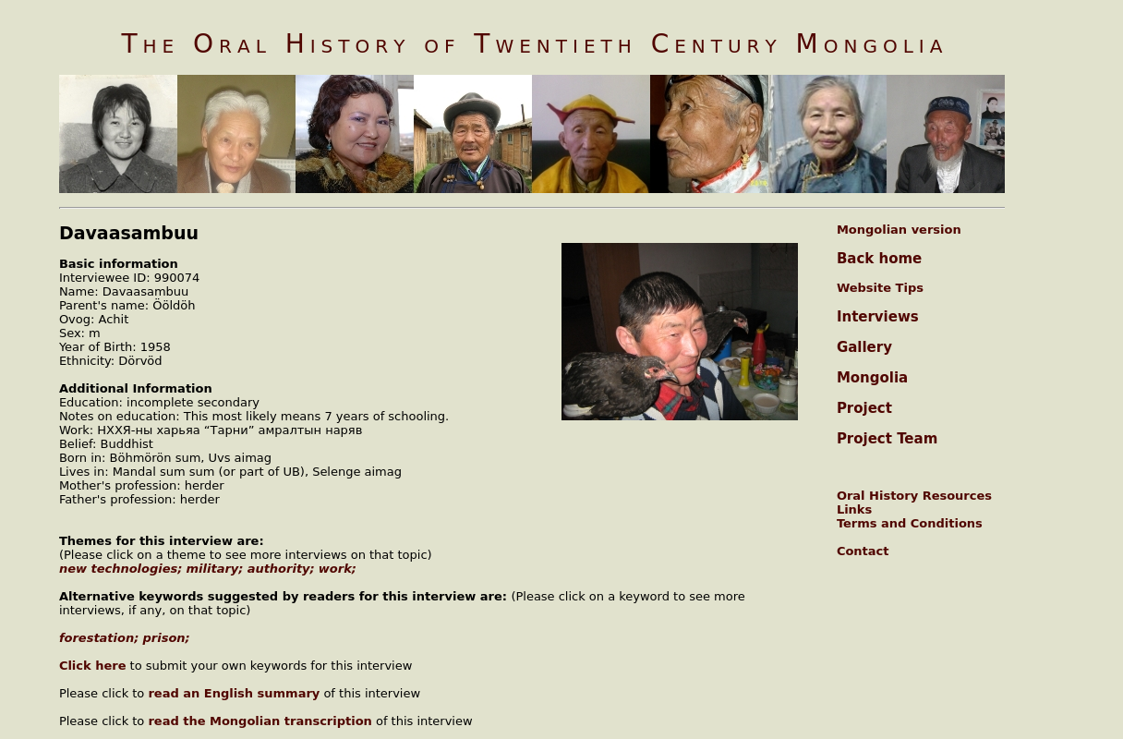

identifier
54a30777-6143-4a91-8b0b-e326751c1032

creator
Davaasambuu

type
Text

coverage
Mongolia
Selenge aimag

description
Oral history interview with Ööldöh Davaasambuu

publisher
Oral History of Twentieth Century Mongolia

source
<http://amantuuh.socanth.cam.ac.uk/search/view_trans.php?Interview=081218B>

rights
Copyright MIASU. Reproduced with permission. Brief excerpts from interviews and other material may be used in academic or popular work for non-commercial purposes provided proper attribution and credit is given to the Oral History of Twentieth Century Mongolia and the Mongolia and Inner Asia Studies Unit (MIASU). You must not: (a) republish this material (including republication on another website) without the express written permission of MIASU; (b) sell, rent or sub-license material from the website; (c) show any material from the website in public without attribution to The Oral History of Twentieth Century Mongolia; (d) reproduce, duplicate, copy or otherwise exploit material on the website for a commercial purpose without express written permission; (e) use the material in any way that is damaging to the project or any of the persons named in the interviews. See <http://amantuuh.socanth.cam.ac.uk/terms.php> for details.

subject
authority
military
new technologies
oral history
prison
work

date
2008

language
English

format
text/plain

contributor
Khishigsüren

original filename
081218B-Davaasambuu-translation.url

relation
4a00d3ab-cb1b-438e-82d6-b0d169215a8c

extent
74.0 B

