С.Жавхлан: Төрсөн өдрөөрөө “Монголд мэндэлсэн өдөр мину” тоглолтоо хийнэ
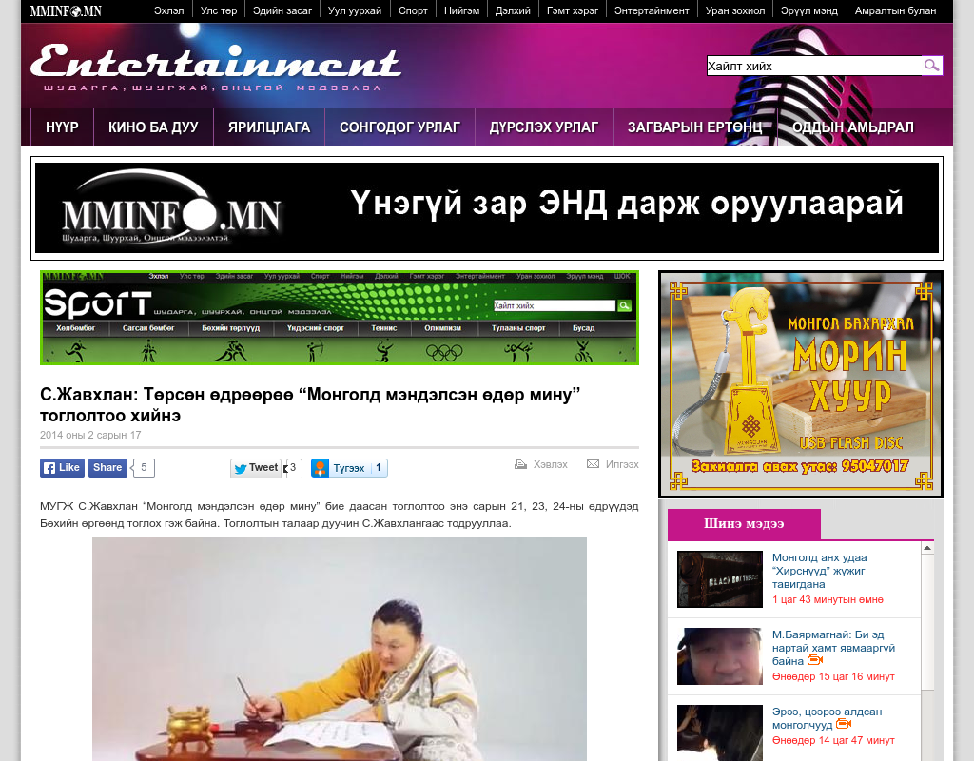

identifier
55ad8d3f-c5a5-4cfa-be3f-2c2b22eee550

creator

type
Text

coverage
Mongolia

description

publisher

source
http://www.mminfo.mn/content/55413.shtml?alias=entertainment

rights

subject
Mongolia
dairy
nationalism
social media

date
24 Mar 2014 17:49:35

language
Mongolian

format
text/plain

modified
2018-01-11 14:12:43

original filename
mminfo.mn.Javkhlan_concert.url

extent
60.0 B

