James Gilmour of Mongolia : his diaries, letters and reports
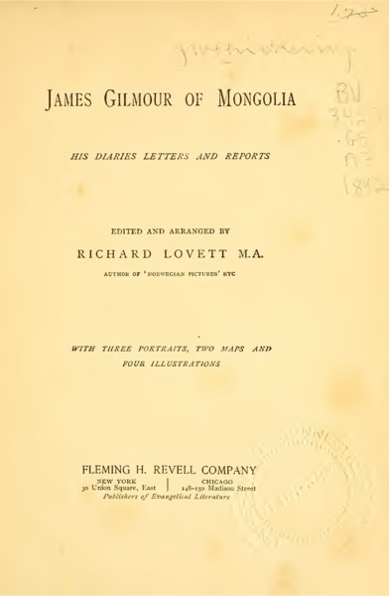

identifier
55e2874c-34ff-4dc7-baa5-bead7123650d

creator
Gilmour, James

type
Text

coverage
Mongolia

description
James Gilmour was a Scottish Protestant missionary who served with the London Missionary Society in Mongolia and China, from 1870 until his death in 1891.

publisher
Fleming H. Revell

source
<https://archive.org/details/jamesgilmourofmo1892gilm>

rights
Public domain

subject
diaries

date
1892

language
English

original filename
jamesgilmourofmo1892gilm.pdf

extent
16.3 MiB

contributor
Lovett, Richard

remote embed url
https://archive.org/embed/jamesgilmourofmo1892gilm

format
application/pdf

modified
2017-10-09 12:50:03

