Caroline Humphrey - Buryatia photos - No. 2-09
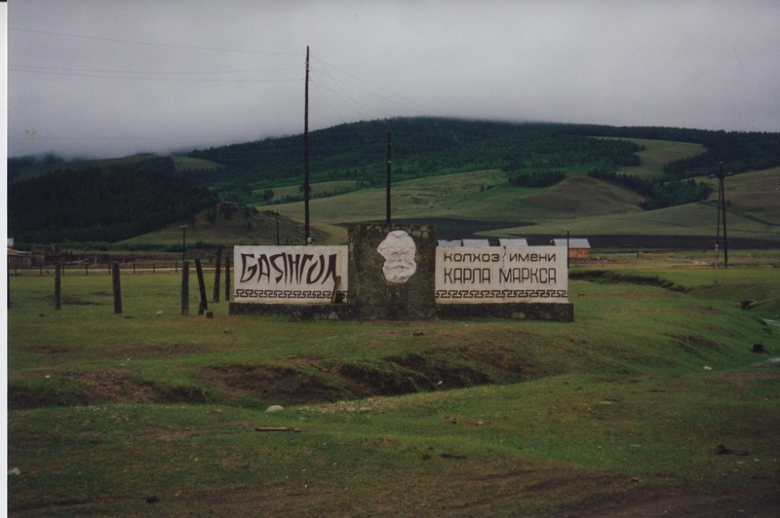

identifier
5774889d-adac-4bf0-8b21-e2cfc5dd1e68

creator
Humphrey, Caroline

type
Image

coverage
Bayangol
Khilgana
Karl Marx Collective
Buryatia
USSR

description
“Karl Marx Collective” sign

publisher

source
Scanned from a print held in the archives of the Mongolia and Inner Asia Studies Unit, University of Cambridge.

rights

subject

date
1993

language

contributor

original filename
Humphrey-Buryatia-photos-2-09.png

relation

extent
3.1MiB
1799x1196 px

format
image/png

