Tuvinian Lama-shamans: Some stories from Mongun-Taiga
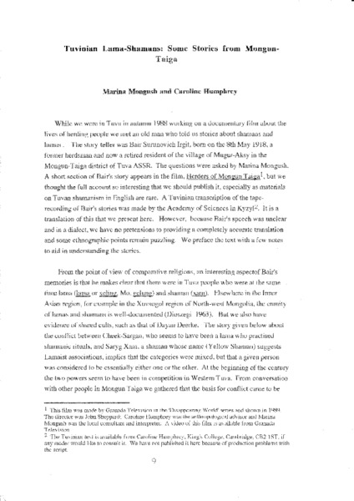

identifier
579733ee-6943-4040-9e2b-efa005bcd8d7

creator
Humphrey, Caroline
Mongush, Marina

type
Text

coverage
Tuva
USSR

description
English translation of a story told by Bair Surunovich Irgit (b. 1918), included in part in the film “Herders of Mongun Taiga”, concerning lama-shamans.

publisher

source
Draft paper from the archives of the Mongolia and Inner Asia Studies Unit, University of Cambridge

rights

subject
Buddhism
divination
shamanism
stories

date
1989

language
English

format
application/pdf

original filename
tuvininan-lama-shamans.pdf

extent
1.8MiB

contributor
Bair Surunovich Irgit

