Photographs from Barguzin, No. 02
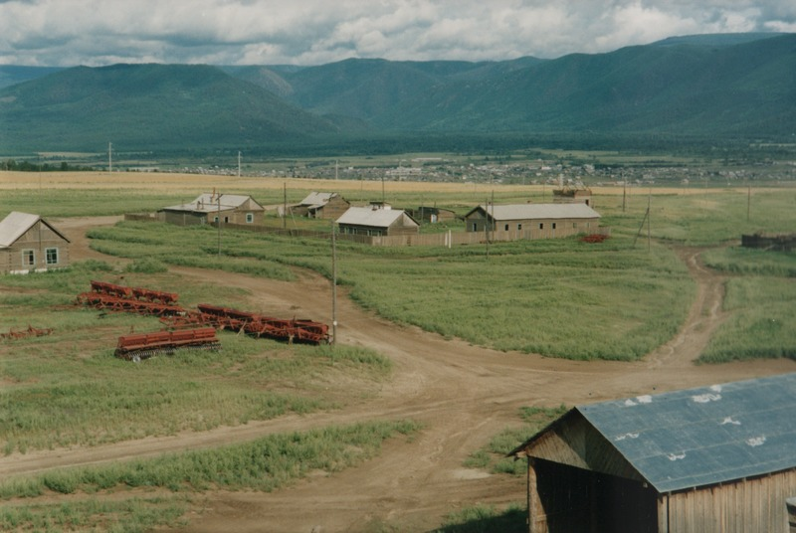

identifier
5a2babe1-614c-43d1-bac2-c199f8473c5b

creator
Gomboev, Bair

type
Image

coverage
Barguzin
Burtyatia
Russian Federation

description
Arable farm centre in Argada selsoviet “Polevoi stan”; in background, the central village of Argada.

date
1993-07

language

format
image/png

modified
2017-05-25 01:57:04

original filename
bair-batbuyan-photos-02.png

source
Scanned from a photographic print held in the archives of the Mongolia and Inner Asia Studies Unit, University of Cambridge

extent
3.2 MiB
1777x1191 px

subject
settlements

