09565-EN
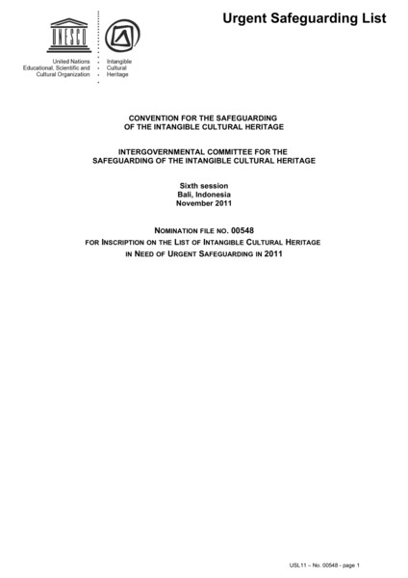

identifier
5a60a286-46d6-49a6-8527-355e52044e78

creator

type
Text

coverage
Mongolia

description
Nomination form. UNESCO List of Intangible Cultural Heritage in Need of Urgent Safeguarding, Nomination file No. 00548, “Coaxing ritual for camels” (Mongolia).

publisher

source

rights

subject

date
2011

language
English

original filename
09565-EN.doc

extent
168.5 KiB

format
application/msword

modified
2012-12-05 01:59:48

