Mongolian ethnicity and linguistic anxiety in China
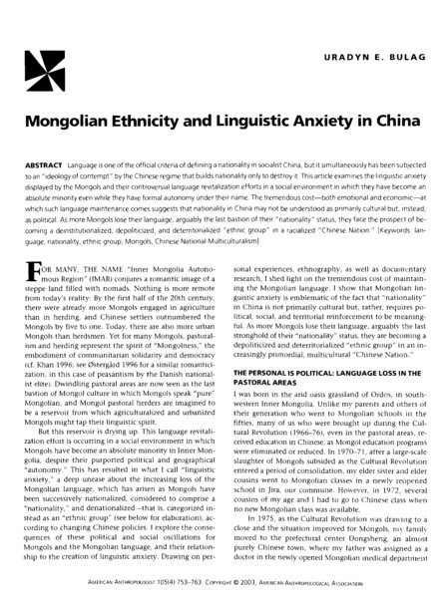

identifier
5b9d4280-5044-4948-84b0-4c4f4b1a02d1

creator
Uradyn E Bulag

type
Text

coverage
Inner Mongolia
PRC

description
Language is one of the official criteria of defining a nationality in socialist China, but it simultaneously has been subjected to an “ideology of contempt” by the Chinese regime that builds nationality only to destroy it. This article examines the linguistic anxiety displayed by the Mongols and their controversial language revitalization efforts in a social environment in which they have become an absolute minority even while they have formal autonomy under their name. The tremendous cost -- both emotional and economic -- at which such language maintenance comes suggests that nationality in China may not be understood as primarily cultural but, instead, as political. As more Mongols lose their language, arguably the last bastion of their “nationality” status, they face the prospect of becoming a deinstitutionalized, depoliticized, and deterritorialized “ethnic group” in a racialized “Chinese Nation”.

publisher
American Anthropologist

source
AMERICAN ANTHROPOLOGIST 105(4):753-763

rights
Copyright American Anthropological Association

subject
Inner Asia
ethnicity
language revitalization

date
2003

language
English

original filename
Bulag2003.pdf

extent
1.6 MiB

format
application/pdf

modified
2014-02-19 05:02:32

