9407
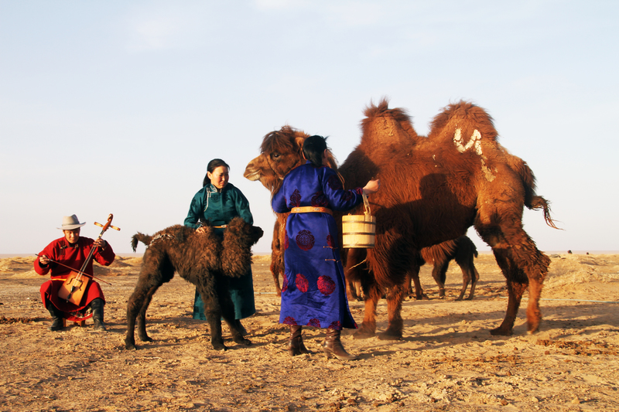

identifier
5bcfa384-a5f6-4d4e-a202-63d13efe3185

creator
Boldbaatar, Yu.

type
Image

coverage
Mongolia
Ömnögovi aimag
Khankhongor sum

description
Coaxed mare-camel and its accepted new calf (Khankhongor Sooum, Umnugobi Province)

publisher

source
https://ich.unesco.org/img/photo/src/09407.jpg

rights

subject

date
2011

language

original filename
09407.jpg

extent
9.1 MiB
5184x3456 px

format
image/jpeg

modified
2016-02-24 14:46:25

