English machine translation of Uradyn Bulag’s 2016 interview
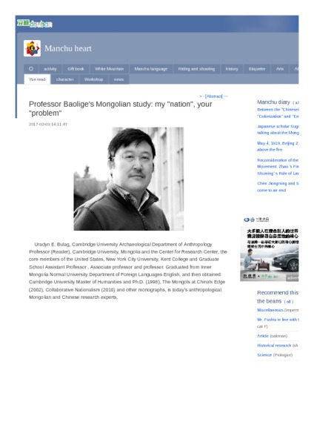

identifier
5be1851a-9ee5-4113-9aae-9114da1746c2

creator
Bulag, Uradyn E

type
Text

coverage
Inner Mongolia
PRC

description
Machine translated version of an interview with Uradyn E. Bulag on nationalism in China.

publisher

source

rights

subject
ethnicity
nationalism

date
2017-06-16 15:23:01

language

extent
1.1MiB

format
application/pdf

contributor

relation
05ecec4a-e53a-4322-bd4f-7690f6b1e538

original_filename
2016-interview-machine-translation-my-nation-your-problem.pdf

public

