Photographs of Dashbalbar sum, No. 27
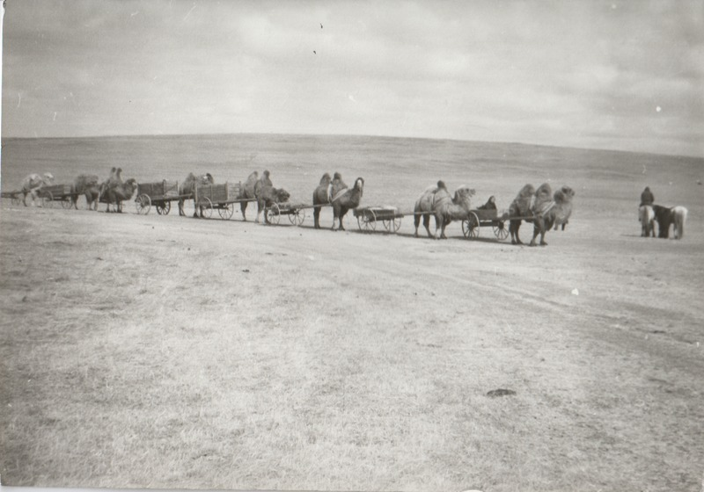

identifier
5dd228cd-34a0-49f3-b455-806dcfe5635d

creator
Batbuyan B.

type
Image

coverage
Dashbalbar sum
Dornod aimag
Mongolia

description
Bazargur’s camels on the way from the sum centre to the spring pasture. HH No. 10 (“rich herder”).

publisher

source
Scanned from a photographic print held in the archives of the Mongolia and Inner Asia Studies Unit, University of Cambridge.

rights

subject
camels
research participants
transportation

date
1993, spring

language

format
image/png

contributor

original filename
bair-batbuyan-photos-27.png

relation

extent
1515x1060 px
2.3 MiB

