Twitter / ShineUkhaan: Ингээд Гоё тараг ...
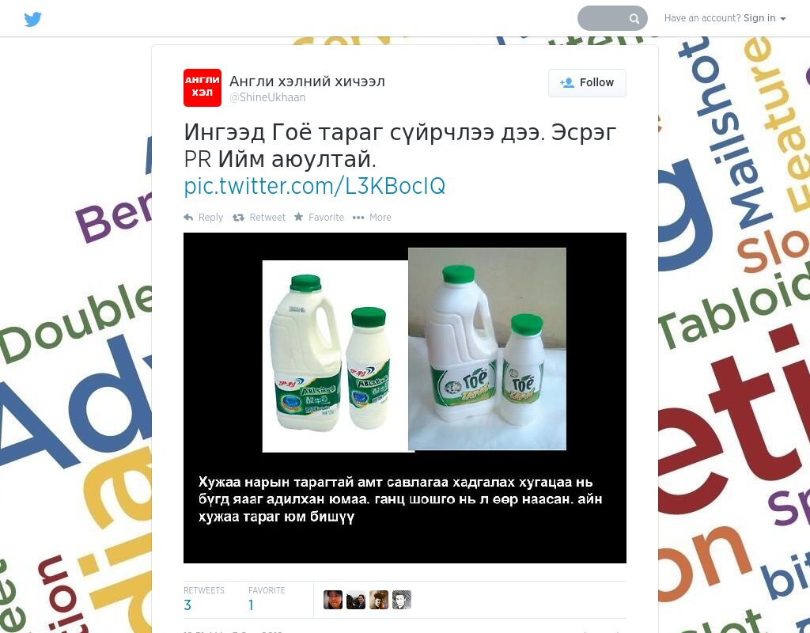

identifier
5de9f784-aa3c-477f-b9a3-7780f2f63e90

creator

type
Text

coverage
Mongolia

description

publisher

source
https://twitter.com/ShineUkhaan/status/242530327589945344

rights

subject
Mongolia
dairy
nationalism
social media

date
8 Jun 2014 16:38:32

language
Mongolian

format
text/plain

modified
2018-01-11 14:12:43

original filename
twitter.com.ShineUkhaan.url

extent
57.0 B

