Photographs from Barguzin, No. 15
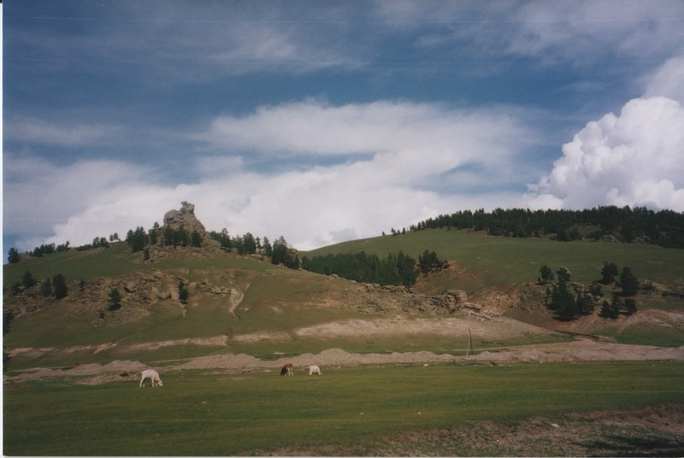

identifier
5efbbbcc-f8a5-4f0b-9543-a31c216bebb4

creator
Gomboev, Bair

type
Image

coverage
Barguzin
Burtyatia
Russian Federation

description
Summer pastures, Barguzin valley, close to the main road in the West part of the valley.

date
1993-07

language

format
image/png

modified
2017-05-25 02:09:40

original filename
bair-batbuyan-photos-15.png

source
Scanned from a photographic print held in the archives of the Mongolia and Inner Asia Studies Unit, University of Cambridge

extent
3.1 MiB
1777x1191 px

subject
rangeland

