6127
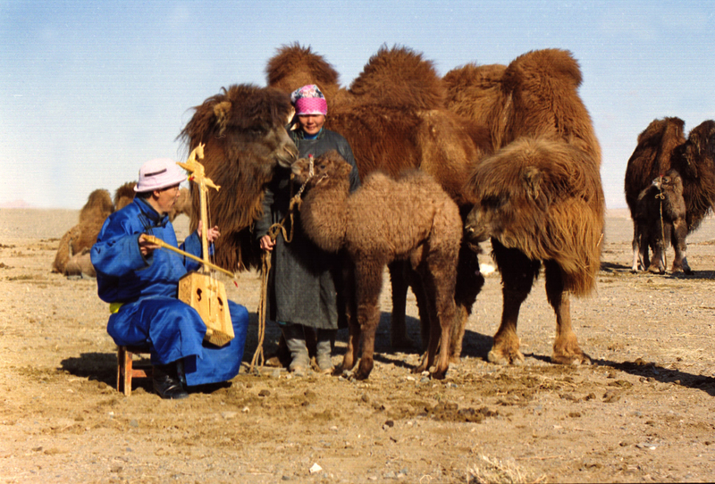

identifier
6109bb3d-0f12-4d31-a6d5-1840f8c0bd83

creator
Boldbaatar, Yu.

type
Image

coverage
Mongolia
Bayankhongor aimag
Bayanlig sum

description
Coaxing ritual for the camel's calves (Bayanlig Soum, Bayankhongor Province)

publisher

source
https://ich.unesco.org/img/photo/src/6127.jpg

rights

subject

date
2011

language

original filename
06127.jpg

extent
2.7 MiB
2655x1800 px

format
image/jpeg

modified
2012-12-05 02:28:25

