2275508. Camel race
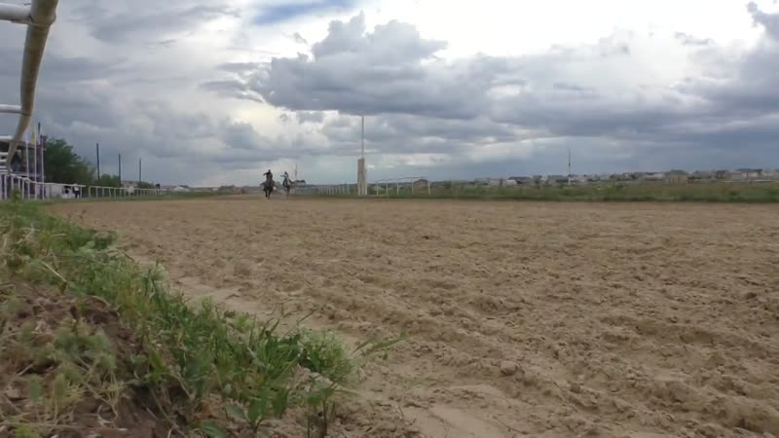

identifier
6384c4f5-a3fa-4018-b67e-760d2361666f

creator

type
Moving Image

coverage
Kalmykia
Russia

description

publisher
University of Cambridge

source
<http://www.kalmykheritage.socanth.cam.ac.uk>

rights
Copyright Kalmyk Cultural Heritage Documentation Project. Licensed under a Creative Commons BY-NC-ND Unported license.

subject
Buddhism
Kalmyks

date
2016-07-06 20:37:50

language

format
video/mp4

contributor

original filename
2275548.mp4

remote embed url
http://sms.cam.ac.uk/media/2275508/embed

relation

extent
170.9 MiB
463.080000

public
FALSE

