Sodnomtsog injecting livestock
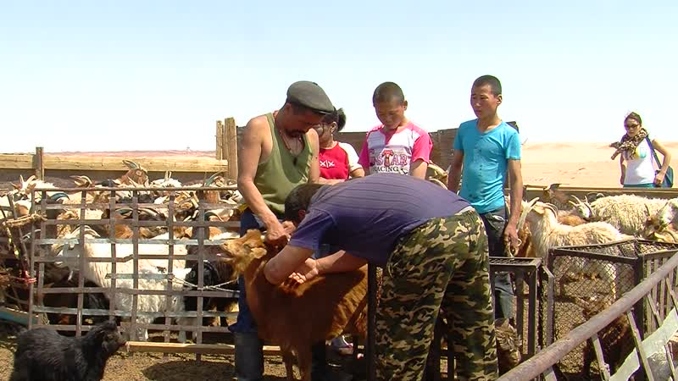

identifier
65108fd4-79a8-4de0-ba84-6e25bae46a08

creator
Thrift, Eric

type
Moving Image

coverage
Mongolia

description
This series of audiovisual recordings shows Sodnomtsog injecting his livestock with an anti-parasitical compound, outside his house at Khamar Monastery. His wife Chimgee, Tsolmon, and several monks help out. After the injections, the sheep and goats are sent over to the well to be watered.

publisher

source

rights

subject
Pastoralism Videos
Innoculating Livestock
Sodnomtsog
Dornogovi-Khamar Monastery

date
2012-05-07

language

format
inode/directory

modified
2018-03-02 09:37:44

original filename
PastoralismVideos--2012-05-07--InnoculatingLivestock--Sodnomtsog--Dornogovi-KhamarMonastery.vclips

table of contents
time | clip | description
0:00:00 | 244 0317 01
0:13:53 | 244 0317 02
0:27:48 | 244 0317 03
0:41:42 | 244 0317 04
0:55:36 | 244 0317 05
0:57:10 | 244 0317 06
1:11:04 | 244 0317 07
1:24:59 | 244 0317 08
1:31:18 | 244 0318 01

