Photograph of Handgate, Xinjiang by Tsui Yen Hu, 1993, No. 07
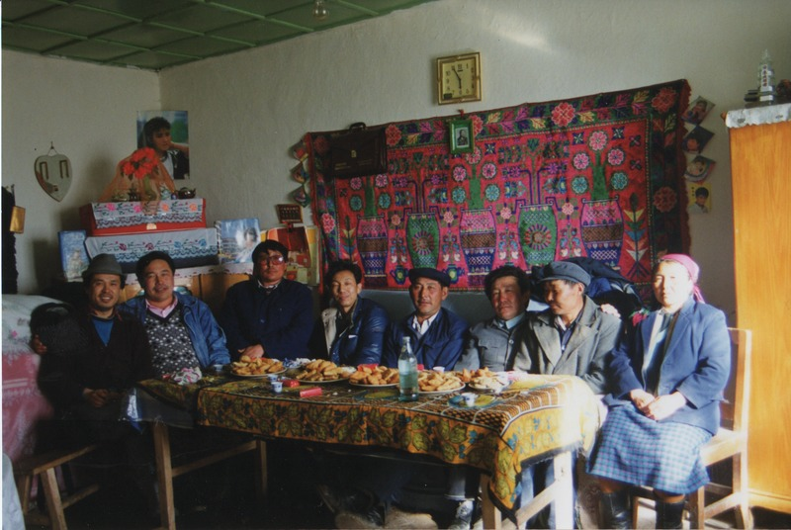

identifier
6685fea9-32c3-4b11-98c0-5e7fa1177eeb

creator
Tsui Yen Hu

type
Image

coverage
Altai district
Handgate
PRC
Xinjiang

description
A reception given to Dr. Omar and Dr. Tsui by the leaders of the Handgate Hsing

publisher

source
Scanned from colour print held in the archives of the University of Cambridge MacArthur Project "Environmental and Cultural Conservation in Inner Asia", Mongolia and Inner Asia Studies Unit.

rights

subject
Handgate centre

date
1993-04-04

language

format
image/png

contributor

original filename
TsuiYenHu-Handgate-1993-07.png

relation

extent
1777x1191 px
3.3 MiB

