"Mongol Temee 2012" [Mongolian Camel 2012] festival (day two).
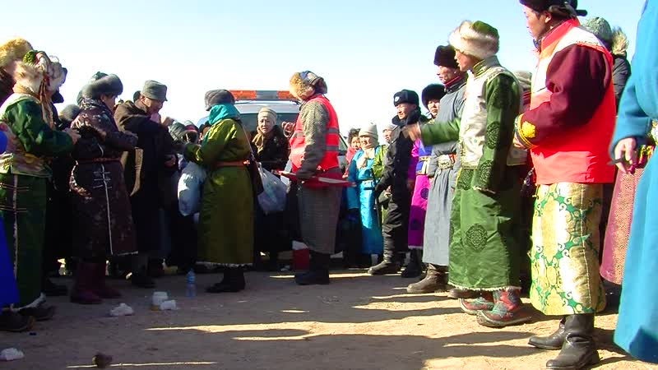

identifier
67fea031-2396-413c-a345-b61118079e8f

creator
Thrift, Eric

type
Moving Image

coverage
Mongolia
Dornogovi aimag
Sainshand sum

description
This series includes videos of events on the second day of the "Mongol Temee 2012" camel festival in Dornogovi. The day begins with a camel race, which is followed by relay races, a whittling competition, and the continuation of camel polo matches in two fields. The festival ends in the afternoon with the handing out of prizes for the camel polo, relay, and whittling competitions, "title calling" (tsol duudakh) of the camel race winners, and announcement of the "best couple" from among participants in the parade.

publisher

source

rights

subject
Pastoralism Videos
Camel Festival
Camel Races
Camel Polo

date
2012-02-12

language

format
inode/directory

modified
2018-01-17 20:15:05

original filename
PastoralismVideos--2012-02-12--CamelFestival--CamelRaces--CamelPolo--Dornogovi-Sainshand.vclips

table of contents
time | clip | description
0:00:00 | 244 0057 01
0:00:33 | 244 0058 01
0:01:20 | 244 0059 01
0:02:12 | 244 0060 01
0:02:53 | 244 0061 01
0:16:48 | 244 0061 02
0:30:11 | 244 0062 01
0:30:46 | 244 0063 01
0:31:17 | 244 0064 01
0:32:27 | 244 0065 01
0:32:40 | 244 0066 01
0:35:13 | 244 0067 01
0:35:29 | 244 0068 01
0:35:34 | 244 0069 01
0:36:06 | 244 0070 01
0:36:27 | 244 0071 01
0:37:25 | 244 0072 01
0:38:01 | 244 0073 01
0:38:57 | 244 0074 01
0:42:30 | 244 0075 01
0:43:02 | 244 0076 01
0:45:56 | 244 0077 01
0:49:41 | 244 0078 01
0:51:49 | 244 0079 01
0:55:20 | 244 0080 01
1:01:47 | 244 0081 01
1:08:22 | 244 0082 01
1:14:53 | 244 0083 01
1:28:48 | 244 0083 02
1:33:44 | 244 0084 01
1:34:59 | 244 0085 01
1:36:16 | 244 0086 01
1:36:56 | 244 0087 01
1:37:50 | 244 0088 01
1:38:37 | 244 0089 01
1:38:51 | 244 0090 01
1:39:38 | 244 0091 01
1:39:41 | 244 0092 01
1:39:46 | 244 0093 01
1:40:40 | 244 0094 01
1:41:51 | 244 0095 01
1:42:14 | 244 0096 01
1:56:08 | 244 0096 02
1:59:45 | 244 0096 03
2:12:00 | 244 0097 01
2:16:48 | 244 0098 01
2:17:35 | 244 0099 01

