Caroline Humphrey Mongolia Super8 film no. 5
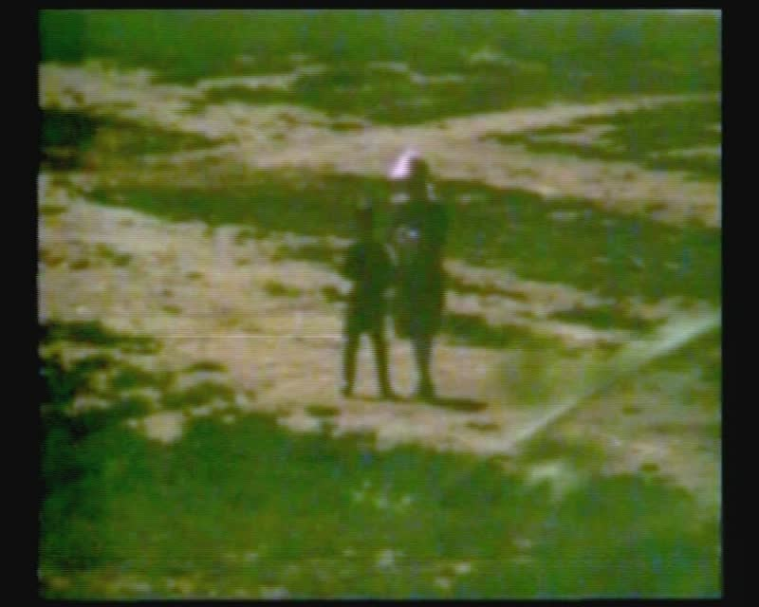

identifier
689c7631-89e8-4c96-94fd-8b1aa9af2a95

creator
Humphrey, Caroline

type
Moving Image

coverage
Arkhangai aimag
Mongolia

description
Tsetserleg (Arkhangai aimag)

publisher
MIASU

source
Digitized from a VCR transfer tape held at the Mongolia and Inner Asia Studies Unit, University of Cambridge

rights
Copyright Caroline Humphrey

subject
aimag centres

date
ca. 1970s

language
None

original filename
humphrey-super8-mongolia-05.mp4

extent
932.5 MiB
199.232000

format
video/mp4

modified
2017-06-16 09:50:26

alternate url
https://archive.org/embed/689c7631-89e8-4c96-94fd-8b1aa9af2a95

