David Sneath - photographs from Xingmeng, Yunnan - No. 01
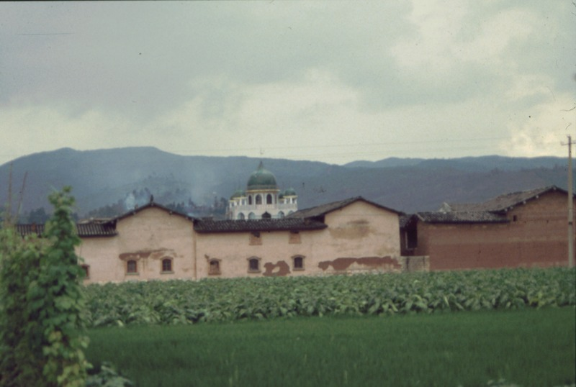

identifier
68f194c6-01eb-4508-8d30-f91b990f530d

creator
Sneath, David

type
Image

coverage
PRC
Yunnan

description
The mosque of the neighbouring Muslim village.

publisher

source
Digitized from a 35mm slide provided by the author.

rights

subject

date
1997

language

format
image/tiff

contributor

original filename
David Sneath - photographs from Xingmeng, Yunnan - No. 01.tif

relation

extent
42.6MiB
4704x3168 px

public

