Grass near Khan Bayanzürkh Mountain, Dornogovi
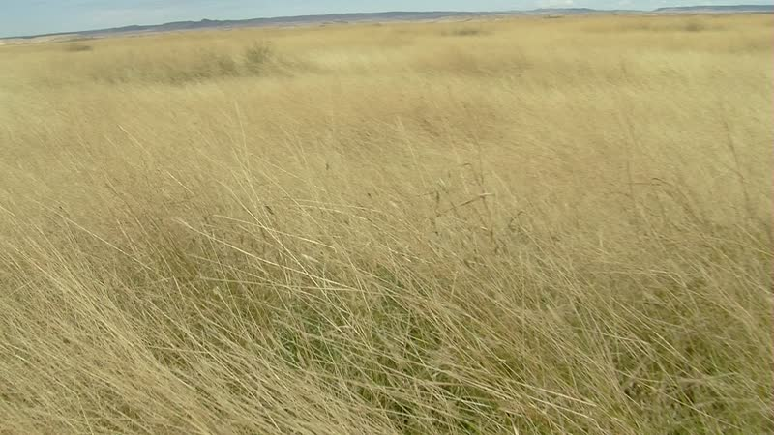

identifier
69e1d9c8-a047-4aca-b7a5-871222bc2ef6

creator
Thrift, Eric

type
Moving Image

coverage
Mongolia
Dornogovi aimag
Sainshand sum

description
This video clip shows an area of tall grass near the site of Delger Farm. Idermönkh and Dolgor from Khamar Monastery visit the site, which they are considering as a place for their daughter and son-in-law (Oyunaa and Nominzul) to spend the winter. There is a winter camp site nearby that they used many years ago, but which has remained abandoned since. Ultimately the family will decide to spend the winter elsewhere, a far distance from the Monastery.

publisher

source

rights

subject
Pastoralism Videos
Grass

date
2012-09-12

language

remote embed url
https://archive.org/embed/69e1d9c8-a047-4aca-b7a5-871222bc2ef6

format
inode/directory

modified
2018-03-02 09:37:44

original filename
PastoralismVideos--2012-09-12--Grass--Dornogovi-Sainshand.vclips

table of contents
time | clip | description
0:00:00 | 300G0165 01

