Caroline Humphrey Mongolia Super8 film no. 15
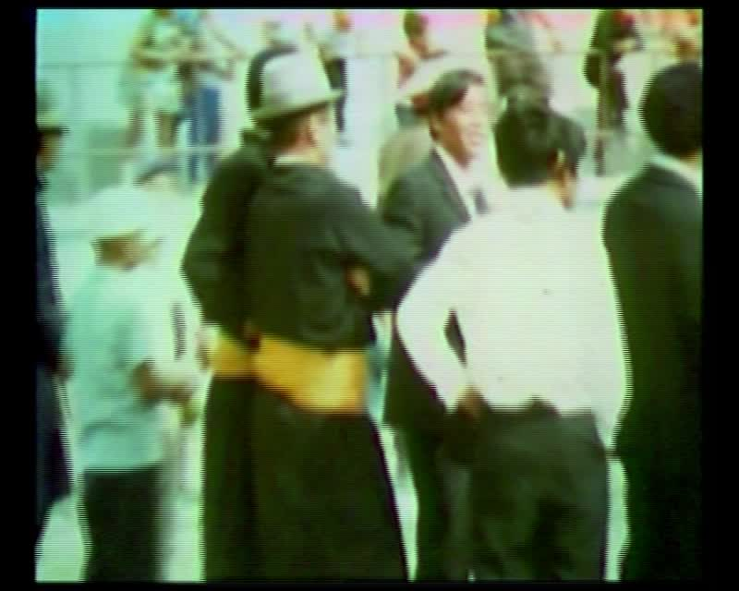

identifier
6ae15804-471c-4acd-87eb-3b838c04d87a

creator
Humphrey, Caroline

type
Moving Image

coverage
Mongolia
Ulaanbaatar

description
Archery competition, Naadam Festival, Ulaanbaatar. Close-up views of competitors and spectators.

publisher
MIASU

source
Digitized from a VCR transfer tape held at the Mongolia and Inner Asia Studies Unit, University of Cambridge

rights
Copyright Caroline Humphrey

subject
Naadam
archery

date
ca. 1970s

language
None

original filename
humphrey-super8-mongolia-15.mp4

extent
895.7 MiB
216.427000

format
video/mp4

modified
2017-06-16 10:52:28

alternate url
https://archive.org/embed/6ae15804-471c-4acd-87eb-3b838c04d87a

