Photographs of Dashbalbar sum, No. 20
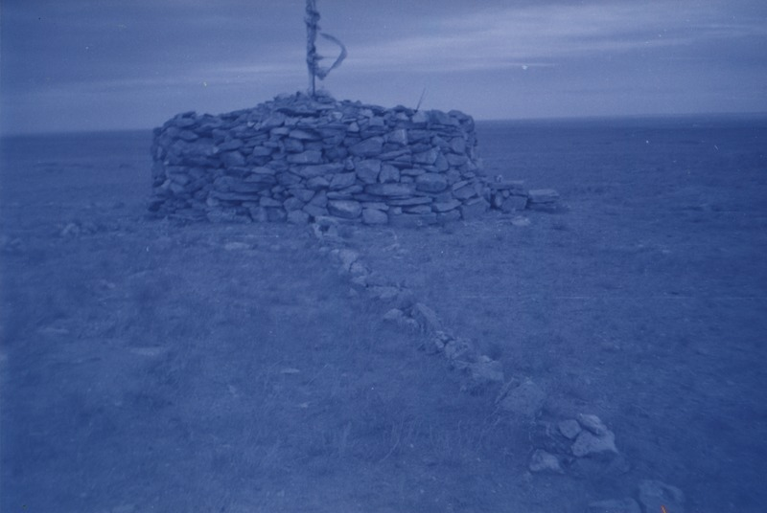

identifier
6df92693-19e0-4966-b26d-a93dae61faf0

creator
Batbuyan B.

type
Image

coverage
Dashbalbar sum
Dornod aimag
Mongolia

description
Ovoo worship in Dashbalbar.

publisher

source
Scanned from a photographic print held in the archives of the Mongolia and Inner Asia Studies Unit, University of Cambridge.

rights

subject
ovoo

date
1993

language

format
image/png

contributor

original filename
bair-batbuyan-photos-20.png

relation

extent
1777x1191 px
2.8 MiB

