Herders of the Mongun Taiga
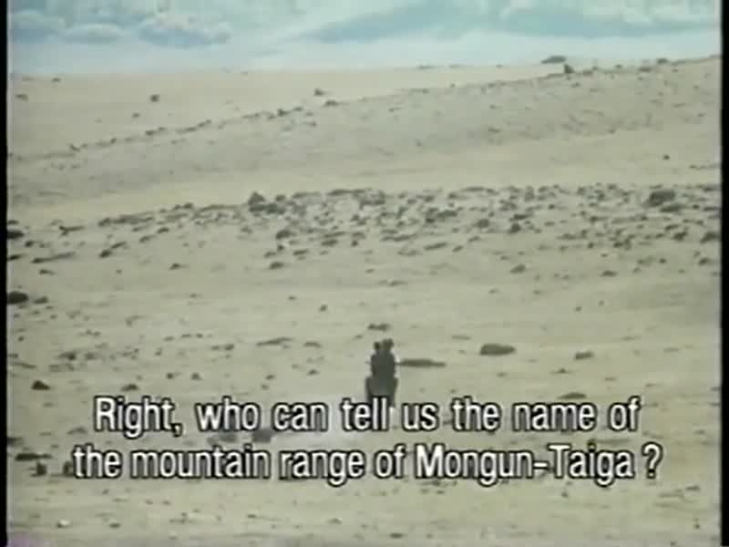

identifier
70636433-042f-464d-91c0-d42291d1950f

creator
Humphrey, Caroline
Sheppard, John

type
Moving Image

coverage
Tuva
USSR

description
Ethnographic film about Tuvan herders and perestroika. The Tuvinians live deep inside the Soviet Union, at the very centre of Asia. Tuva is geographically closer to Beijing than to Moscow. It only entered the USSR in 1944 and was closed to foreigners until 1988. According to the film-makers the last known British visitors were members of the Carruthers expedition in 1910--11. With "glasnost", the new openness, a Disappearing World film crew was given permission to film the nomadic yak-herders of Mongun-Taiga, a rugged district on the border with Mongolia. Mongun-Taiga or "sacred wilderness" is, even at its lowest point, 6,000 feet above sea level. Two huge mountains dominate the landscape and provide a stunning backdrop for the film, accompanied at times on the film sound track by the traditional throat singing. Arable farming is impossible and the inhabitants are dependent on the nomadic herding of yak, sheep, goats and horses. Families live alone or in groups of two to three felt tents (yurts). Following the seasons and the pastures, they move camp several times each year. The film looks at the methods the herders use to protect their children from destructive spirits. A child, dressed in a traditional frock, is revealed in the film to be a boy. This cross-dressing of the sexes continues until a child is three or four, when it is believed that its soul is more firmly attached to its body and not so easily stolen by spirits. Shamanic beliefs continue, despite state disapproval, and include worship of the spirits of mountains, purification by the water of sacred springs, sacrifice, and the use of animals in exorcism, omens and divination. The opportunities for modern Soviet life which attract many young people are countered by the pull of an independent Mongolia, which is much closer to the Tuvinians in culture and way of life. Under Gorbachev, new systems of herding have been introduced which allow families to work for themselves as well as the state farms. The herders, however, still have reservations about the new ways. "How are you doing with perestroika?" asks the daughter of Chugluur-Ool, a herder. "Perestroika's doing all right," he replies. Part of what makes this film interesting is the film-makers' admission of the material they were not able to obtain. Continually throughout the film, the narrator mentions the confusion and frustration the film-makers felt. This gives a refreshing honesty to the film as a whole.

publisher
Royal Anthropological Institute

source
<https://search.alexanderstreet.com/preview/work/2086388>

rights
Copyright. Contact the RAI for licensing and use.

subject
gender
pastoralism
shamanism
socialism

date
1989

language
English
Tuvan

original filename
herders-of-mongun-taiga.mkv

relation
3a3f3bc2-b626-4731-8f99-984cf4f4ee97

extent
260.5 MiB
2975.310000

contributor
Disappearing World Films

format
video/x-matroska

remote embed url
https://search.alexanderstreet.com/embed/token/05l74chg70r36e1o

public
FALSE

