Vitafit factory tour image - 5gt48oc18lrrtpbs95qea7056b l
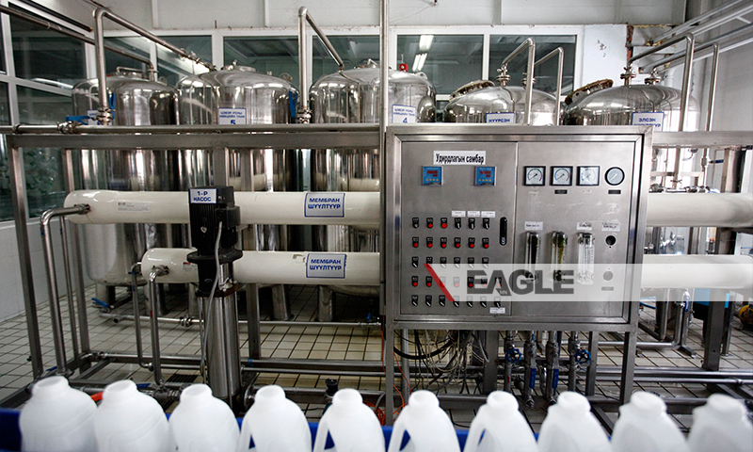

identifier
70febab4-e14b-4456-871a-2605b21304f2

creator

type
Image

coverage
Mongolia

description
Goyo yogurt factory tour image published by Eagle.mn.

publisher

source

rights

subject
Mongolia
dairy
nationalism
social media

date
2014

language
Vitafit factory tour image - Vitafit factory tour image - 5gt48oc18lrrtpbs95qea7056b l

format
image/jpeg

original filename
5gt48oc18lrrtpbs95qea7056b_l.jpg

extent
422.0 KiB
800x480 px

modified
2014-03-24 18:29:14

