30374-EN
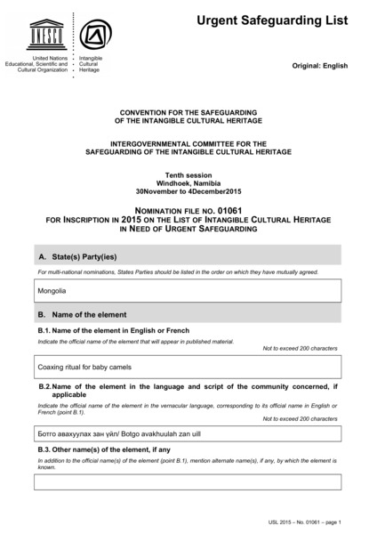

identifier
713073da-3651-42c5-95f2-4edb2eeea669

creator
Mongolia

type
Text

coverage
Mongolia

description
Nomination form. UNESCO List of Intangible Cultural Heritage in Need of Urgent Safeguarding, Nomination file No. 01061, “Coaxing ritual for camels” (Mongolia).

publisher

source

rights

subject

date
2015

language
English

original filename
30374-EN.doc

extent
206.5 KiB

format
application/msword

modified
2016-02-24 14:44:40

