Milking goats at San and Saraa's place, Dornogovi
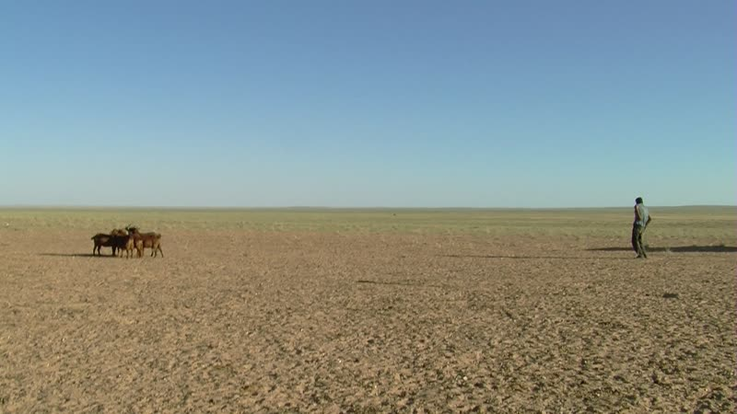

identifier
71577f52-5bc7-400a-8a43-f9965722a543

creator
Thrift, Eric

type
Moving Image

coverage
Mongolia

description
This series of audiovisual recordings documents an evening visit to San and Saraa's place, about 30 km south of Khamar Monastery. Their son, a monk at the Monastery, fills up canisters of drinking water from a well to bring to the family. Saraa and her daughter milk the goats. Back at the Monastery, Togtokh Lama's daughter and grandson milks the family's camels.

publisher

source

rights

subject
Pastoralism Videos
Milking Goats
San-Saraa
Dornogovi-Ulaanbadrakh

date
2012-09-06

language

remote embed url
https://archive.org/embed/71577f52-5bc7-400a-8a43-f9965722a543

format
inode/directory

modified
2018-03-02 09:37:44

original filename
PastoralismVideos--2012-09-06--MilkingGoats--San-Saraa--Dornogovi-Ulaanbadrakh.vclips

table of contents
time | clip | description
0:00:00 | 300G0110 01
0:03:12 | 300G0111 01
0:23:19 | 300G0112 01
0:26:40 | 300G0113 01
0:40:33 | 300G0113 02
0:54:27 | 300G0113 03
0:56:32 | 300G0114 01
1:10:26 | 300G0114 02
1:24:20 | 300G0114 03
1:38:13 | 300G0114 04

