Photograph from Govisumber, No. 30
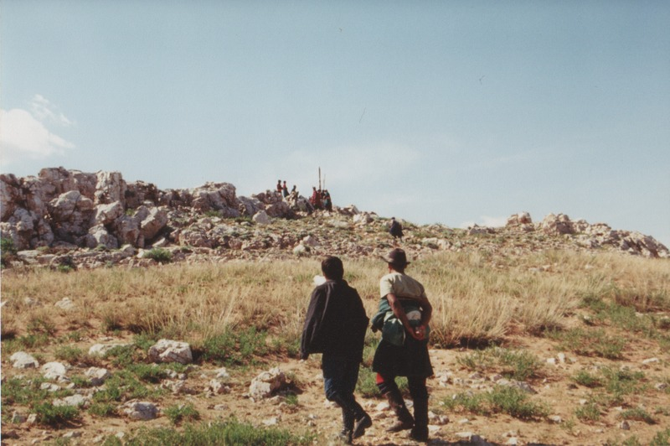

identifier
72609532-78bc-4761-87ad-e0a9a60a4300

creator
Sneath, David

type
Image

coverage
Govisumber aimag
Mongolia

description

publisher

source
scanned from a photographic print held in the archives of the Mongolia and Inner Asia Studies Unit, University of Cambridge

rights

subject
ovoo

date
1995

language

format
image/png

contributor

original filename
sneath-govisumber_30.png

relation

extent
1776x1182 px
3.3MiB

