Caroline Humphrey - Buryatia photos - No. 4-12
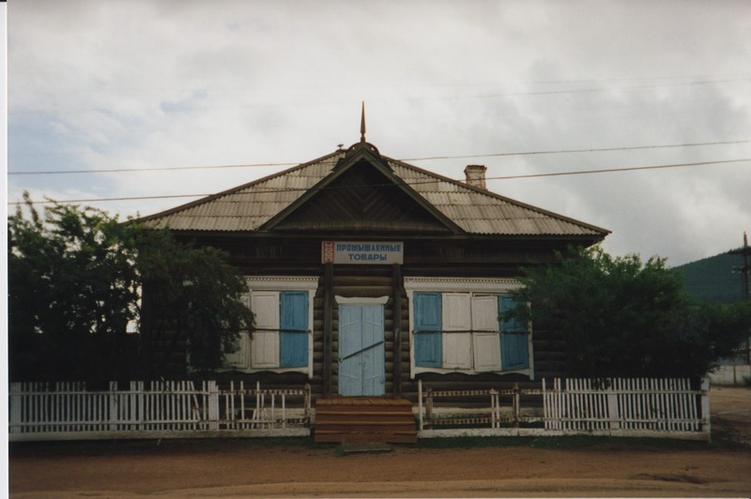

identifier
7677f0a6-e97b-4c43-82c2-bea1a23251fc

creator
Humphrey, Caroline

type
Image

coverage
Uro
Bayangol
Buryatia
USSR

description
Industrial goods store.

publisher

source
Scanned from a print held in the archives of the Mongolia and Inner Asia Studies Unit, University of Cambridge.

rights

subject

date
1993

language

contributor

original filename
Humphrey-Buryatia-photos-4-12.png

relation

extent
3.1MiB
1799x1196 px

format
image/png

