Images from the collections of the Dornogovi aimag museum, taken on the occasion of the Mongol Temee-2012 Camel Festival.
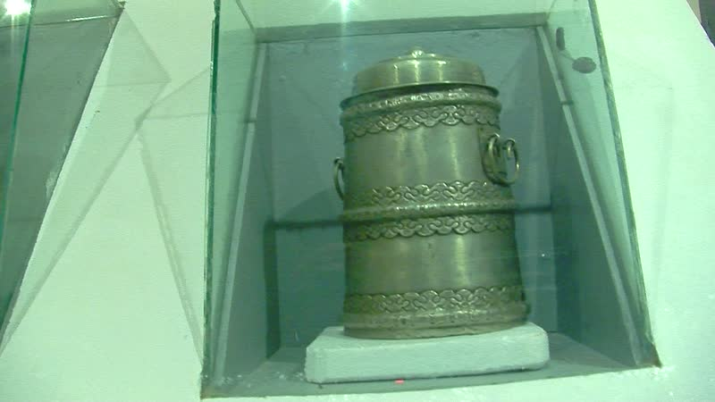

identifier
7946fac4-4d63-4170-9703-8eaa6fc39e99

creator
Thrift, Eric

type
Moving Image

coverage
Mongolia
Dornogovi aimag
Sainshand sum

description
This series includes a several short video recordings in which curator G. Sarangerel presents the display of camel-related ethnographic objects at the Dornogovi aimag museum. These museum objects include riding equipment, various pots and containers, and works of art by local artists representing camels.

publisher

source

rights

subject
Pastoralism Videos
Camel Festival
Aimag Museum
Ethnographic Collections

date
2012-02-13

language

format
inode/directory

modified
2018-01-17 20:15:05

original filename
PastoralismVideos--2012-02-13--CamelFestival--AimagMuseum--EthnographicCollections--Dornogovi-Sainshand.vclips

table of contents
time | clip | description
0:00:00 | 244 0100 01 | Curator Sarangerel presents the display of camel-related ethnographic objects at the Dornogovi aimag museum.
0:02:37 | 244 0101 01 | Traditional style painting of pastoral activities, including one person riding a camel, two on horseback, and two people milking a camel.
0:02:47 | 244 0102 01 | Curator Sarangerel describes the ethnographic collections in the Dornogovi provincial museum, including a bat used in camel polo competition.
0:10:53 | 244 0103 01 | Stuffed camel and display case containing camel-related items in the Dornogovi provincial museum.
0:12:58 | 244 0104 01 | *Mongol zurag* national style painting in the Dornogovi provincial museum, depicting camel-related activities of the Gobi.
0:13:07 | 244 0105 01 | Various pots in the non-display collections of the Dornogovi provincial museum.
0:14:15 | 244 0106 01 | Cut paper art (khaichilbar) in the collection of the Dornogovi provincial museum, showing a camel in heat.

