Photograph from Govisumber, No. 23
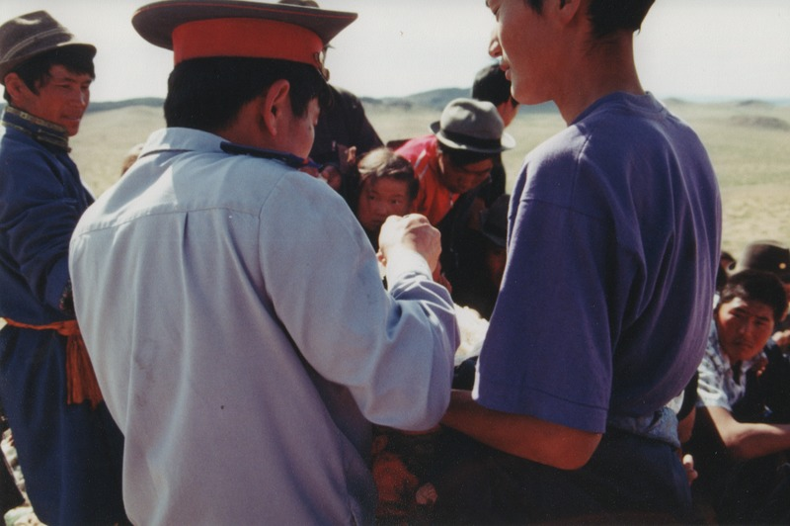

identifier
7a242e84-d76d-4404-be92-df2e9dda04eb

creator
Sneath, David

type
Image

coverage
Govisumber aimag
Mongolia

description

publisher

source
scanned from a photographic print held in the archives of the Mongolia and Inner Asia Studies Unit, University of Cambridge

rights

subject
offerings (ideenii tavag)
ovoo

date
1995

language

format
image/png

contributor

original filename
sneath-govisumber_23.png

relation

extent
1776x1182 px
3.1MiB

