Spring: Figures from “Living with Herds”
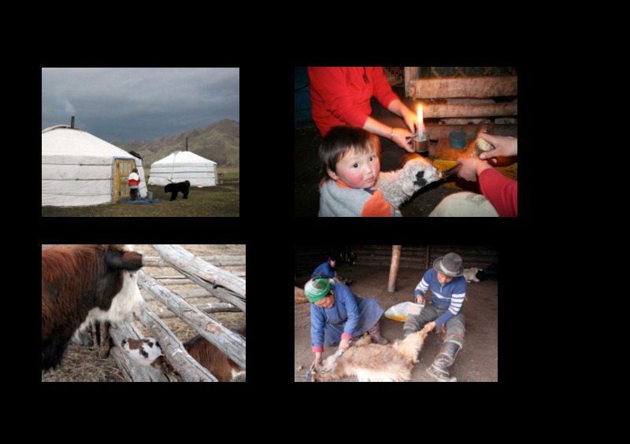

identifier
7ae4a2e1-9940-48f8-9687-a97c25882263

creator
Fijn, Natasha

type
Text

coverage
Mongolia

description

publisher

source
<http://www.cambridge.org/us/academic/subjects/archaeology/archaeology-europe-and-near-and-middle-east/living-herds-human-animal-coexistence-mongolia?format=HB&isbn=9781107000902#Je3whAJbJX4jZR5A.97>

rights
These resources are provided free of charge by Cambridge University Press with permission of the author of the corresponding work, but are subject to copyright. You are permitted to view, print and download these resources for your own personal use only, provided any copyright lines on the resources are not removed or altered in any way.

subject

date
2011

language
English

format
application/pdf

contributor

original filename
9848_Spring.pdf

remote embed url

relation

extent
756.6KiB

