ECCIA project interim report timetable
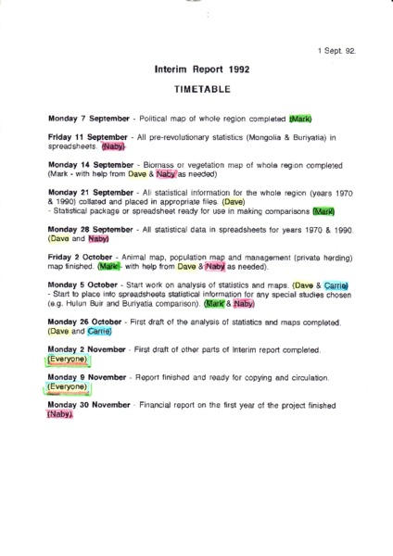

identifier
7b40ea4d-f8c1-422e-acac-bc2a8f9ec211

creator

type
Text

coverage

description

publisher

source
Scanned from an original document held in the archives of the Mongolia and Inner Asia Studies Unit, University of Cambridge.

rights

subject

date
ca. 1992

language

original filename
macarthur-interim-report-timetable.pdf

relation

extent
520.2 KiB

contributor

format
application/pdf

modified
2017-05-25 18:48:17

