Photograph from Govisumber, No. 14
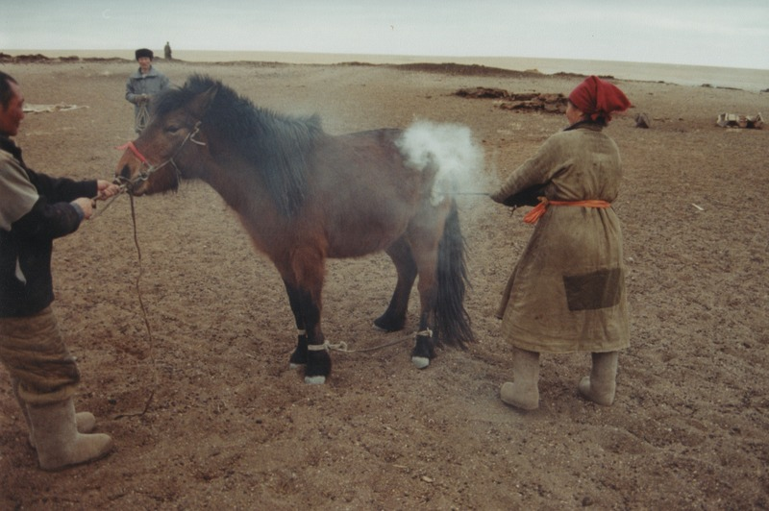

identifier
7b919fed-0c86-4774-b01c-5f321aa8ba1f

creator
Sneath, David

type
Image

coverage
Govisumber aimag
Mongolia

description

publisher

source
scanned from a photographic print held in the archives of the Mongolia and Inner Asia Studies Unit, University of Cambridge

rights

subject
branding foals

date
1995

language

format
image/png

contributor

original filename
sneath-govisumber_14.png

relation

extent
1776x1182 px
3.2MiB

