Хүнсний аюулгүй байдал — хортой сүү, самар, тос
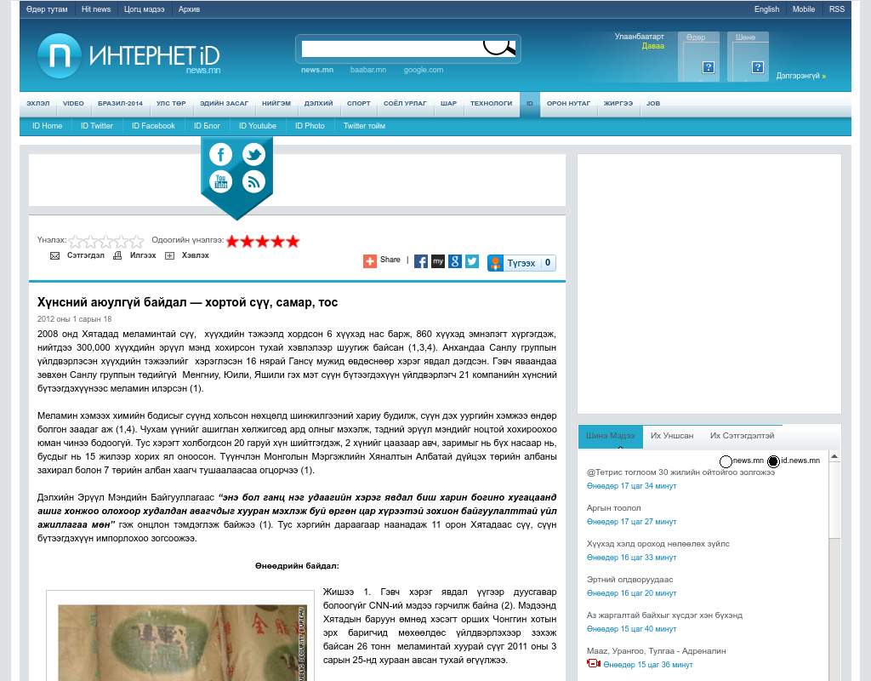

identifier
7cdd1688-8f27-4805-85d0-fa5ff0a02df1

creator

type
Text

coverage
Mongolia

description

publisher

source
http://id.news.mn/content/94060.shtml

rights

subject
Mongolia
dairy
nationalism
social media

date
9 Jun 2014 20:56:07

language
Mongolian

format
text/plain

modified
2018-01-11 14:12:43

original filename
news.mn.Khortoi_suu.url

extent
37.0 B

