Caroline Humphrey Mongolia Super8 film no. 4
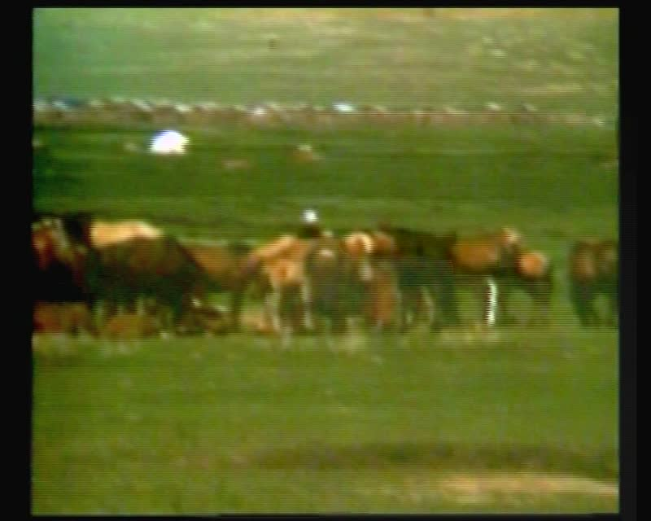

identifier
7cef6c99-b85e-4472-afea-6c420af5ae83

creator
Humphrey, Caroline

type
Moving Image

coverage
Mongolia

description
Herding, camp, milking

publisher
MIASU

source
Digitized from a VCR transfer tape held at the Mongolia and Inner Asia Studies Unit, University of Cambridge

rights
Copyright Caroline Humphrey

subject
herding
milking

date
ca. 1970s

language
None

original filename
humphrey-super8-mongolia-04.mp4

extent
920.5 MiB
218.518000

format
video/mp4

modified
2017-06-16 09:43:05

alternate url
https://archive.org/embed/7cef6c99-b85e-4472-afea-6c420af5ae83

