Photographs of Dashbalbar sum, No. 44
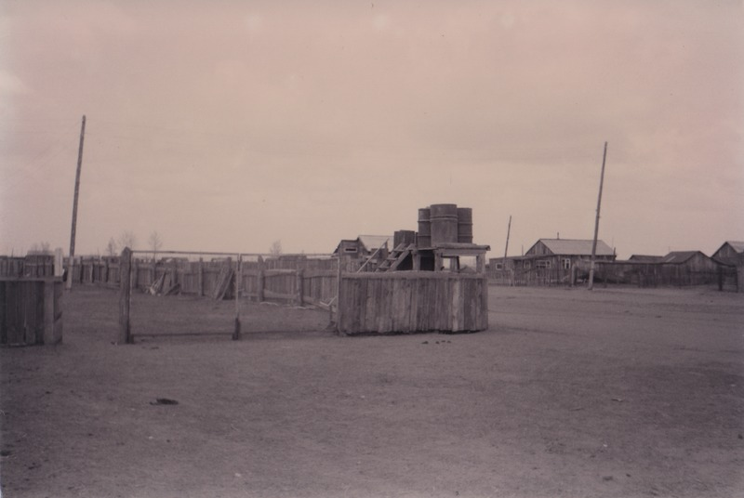

identifier
825f8954-65eb-451b-bb08-e8ca0b4f863c

creator
Batbuyan B.

type
Image

coverage
Dashbalbar sum
Dornod aimag
Mongolia

description
Dustbins for rubbish, Dashbalbar sum centre.

publisher

source
Scanned from a photographic print held in the archives of the Mongolia and Inner Asia Studies Unit, University of Cambridge.

rights

subject
garbage
settlements

date
ca. 1995

language

format
image/png

contributor

original filename
bair-batbuyan-photos-44.png

relation

extent
1764x1181 px
2.6 MiB

