&quot;Оргил хүнс&quot; хятад тараг савлав уу
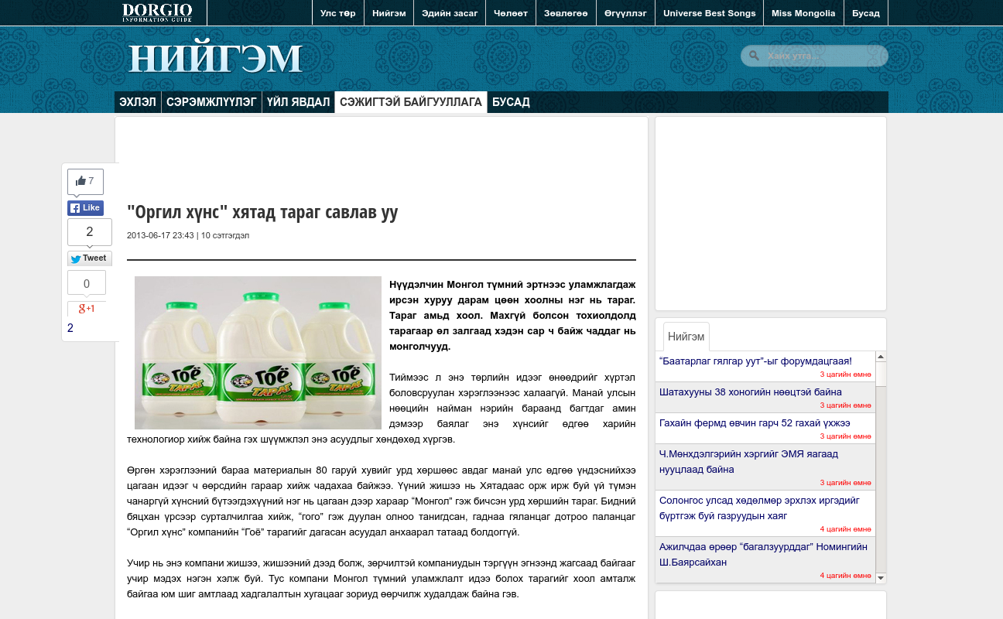

identifier
87ff6e20-36f2-4bc4-bdd1-eb7134837f98

creator

type
Text

coverage
Mongolia

description

publisher

source
http://news.dorgio.mn/society/sejigtei/2820

rights

subject
Mongolia
dairy
nationalism
social media

date
24 Mar 2014 14:54:15

language
Mongolian

format
text/plain

modified
2018-01-11 14:12:43

original filename
news.dorgio.mn.Khyatad_tarag_savlav_uu.url

extent
43.0 B

