Moving - Noogii and Enkhee
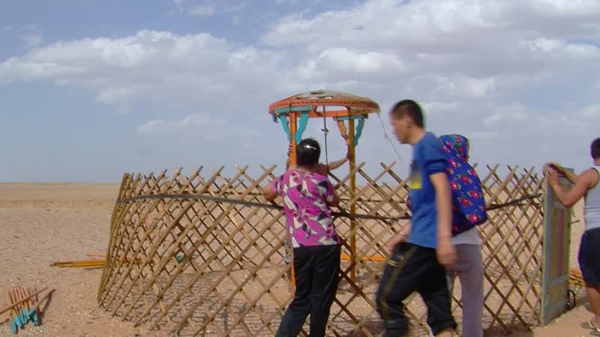

identifier
88143c02-5cfe-4c56-ae96-d266c59fc518

creator
Thrift, Eric

type
Moving Image

coverage
Mongolia
Dornogovi aimag
Sainshand sum

description
This series of audiovisual recordings shows Noogii and Enkhee moving from their winter/spring camp to a temporary summer camp nearby. Several monks from Khamar Monastery come to help out with the move. The recordings start with the yurt being taken down (the outer cover [bürees] has already been removed), and packing of the yurt and some furniture into the back of a van, normally used for transporting pilgrims arriving by train in Sainshand. The family are leaving behind their beds and other large furniture, which will be stored in a shed at the winter camp. After a short drive to the new camp site, the van is unpacked and the men set up the yurt and bring in the main furniture, which Enkhee arranges.

publisher

source

rights

subject
Pastoralism Videos
Moving Camps
Noogii-Enkhee

date
2012-05-09

language

format
inode/directory

modified
2018-03-02 09:37:44

original filename
PastoralismVideos--2012-05-09--MovingCamps--Noogii-Enkhee--Dornogovi-Sainshand.vclips

table of contents
time | clip | description
0:00:00 | 244 0319 01
0:13:54 | 244 0319 02
0:27:48 | 244 0319 03
0:33:07 | 244 0320 01
0:47:02 | 244 0320 02
0:47:24 | 244 0321 01
0:50:05 | 244 0322 01
0:53:39 | 244 0323 01
1:07:33 | 244 0323 02
1:21:27 | 244 0323 03
1:35:21 | 244 0323 04
1:49:15 | 244 0323 05
2:00:04 | 244 0323 06
2:13:58 | 244 0323 07

