Planting trees with Tsolmon at Khamar Monastery
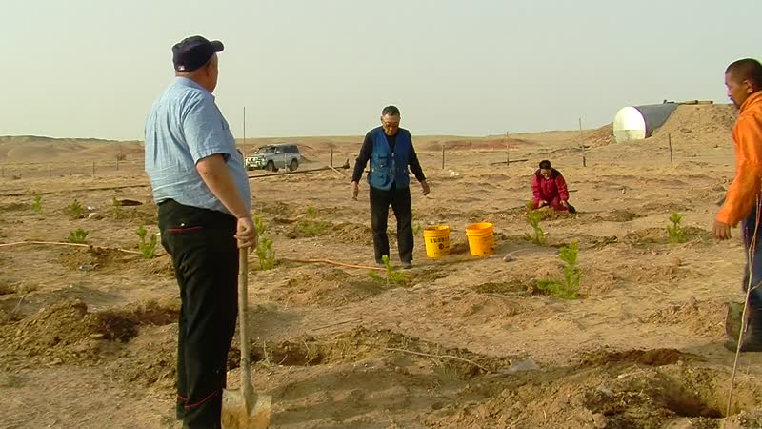

identifier
88e66615-3547-4ae8-b29c-10b653a0cc4d

creator
Thrift, Eric

type
Moving Image

coverage
Mongolia

description
This series of audiovisual recordings documents tree-planting with Tsolmon at his plantation at Khamar Monastery, just after dawn. The saplings, from a nursery in Selenge, have been donated by Tsolmon's uncle Tsuilan, Tsuilan's brother-in-law Byambasüren, and Byambasüren's son Naranbaatar, who have all come from Ulaanbaatar to participate in the tree planting. Tsolmon provides instructions on how to dig holes for the trees, add manure fertilizer, and water the saplings.

publisher

source

rights

subject
Pastoralism Videos
Planting Trees
Tsolmon
Dornogovi-Khamar Monastery

date
2012-05-05

language

format
inode/directory

modified
2018-03-02 09:37:44

original filename
PastoralismVideos--2012-05-05--PlantingTrees--Tsolmon--Dornogovi-KhamarMonastery.vclips

table of contents
time | clip | description
0:00:00 | 244 0312 01
0:13:53 | 244 0312 02
0:27:48 | 244 0312 03
0:41:42 | 244 0312 04
0:47:39 | 244 0313 01
1:01:34 | 244 0313 02
1:15:28 | 244 0313 03
1:29:22 | 244 0313 04
1:43:17 | 244 0313 05

