Owen Lattimore interviewed by Caroline Humphrey, 21st May 1983 – Part 1
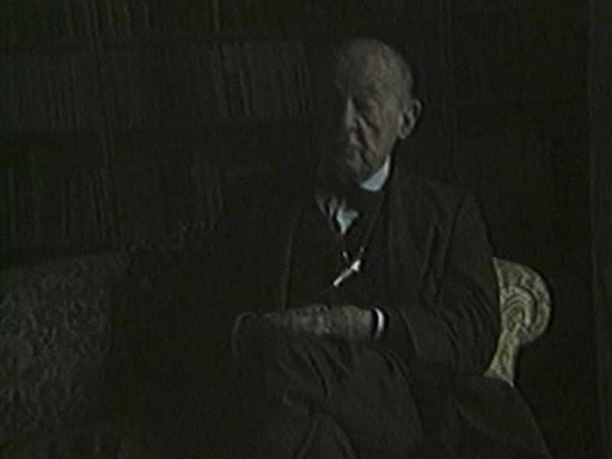

identifier
8952fa21-96c7-4467-b2ce-6983a0c50d94

creator
Lattimore, Owen

type
Moving Image

coverage
Mongolia
China

description
Owen Lattimore describes Mongolia of the early 20th century and the aftermath of revolutions in that period. He discusses how he came to China and Mongolia; his training and efforts to learn Mongolian; caravans, trade, and currency in the pre-Revolutionary period; his participation in a caravan; labour relations in nomadic pastoral society, and the place of Mongolian pastoralism in cultural evolution; the role of women; social stratification; Russian presence in Mongolia; changes since his first visit; Kazakhs.

publisher

source

rights

subject
pastoral life
labour relations
gender
social stratification
Russians in Mongolia
Kazakhs in Mongolia

date
1983

language
English

contributor
Humphrey, Caroline

original filename
lattimore1.mp4

relation

extent
359.8 MiB
4157.040000

format
video/mp4

modified
2017-05-25 02:44:40

remote embed url

public

