Camel husbandry at Tomor and Jargal's winter camp.
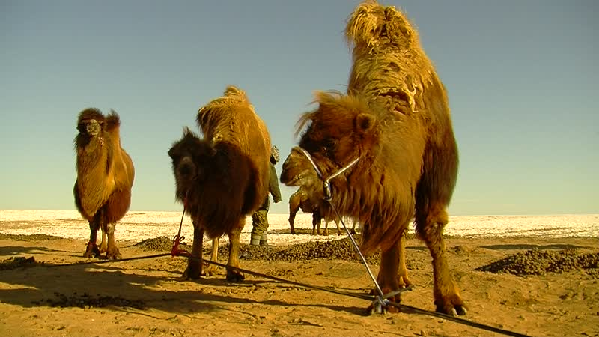

identifier
897f5f00-da00-4a93-a1f2-b1bd1bd8caff

creator
Thrift, Eric

type
Moving Image

coverage
Mongolia
Dornogovi aimag
Örgön sum

description
The recordings in this series depict the morning activities at Tomor and Jargal's camp in late winter/early spring, specifically milking camels and sending the sheep and goats off to graze.

publisher

source

rights

subject
Pastoralism Videos
Milking Camels
Morning Activities
Tomor-Jargal

date
2012-02-16

language

format
inode/directory

modified
2018-01-17 20:16:46

original filename
PastoralismVideos--2012-02-16--MilkingCamels--MorningActivities--Tomor-Jargal--Dornogovi-Orgon.vclips

table of contents
time | clip | description
0:00:00 | 244 0107 01 | At Tomor and Jargal's winter camp. Jargal milks the camels, as Tomor helps to bring each calf to its mother to suckle before being milked.
0:13:53 | 244 0107 02 | Tomor hitches the camels.
0:15:42 | 244 0108 01 | Tomor sends the camels off to graze. He discusses his herding (off-camera). Tomor walks back towards the home.
0:23:48 | 244 0109 01 | Tomor sends off his sheep and goats to graze.

