Photograph of Handgate, Xinjiang by Tsui Yen Hu, 1993, No. 30
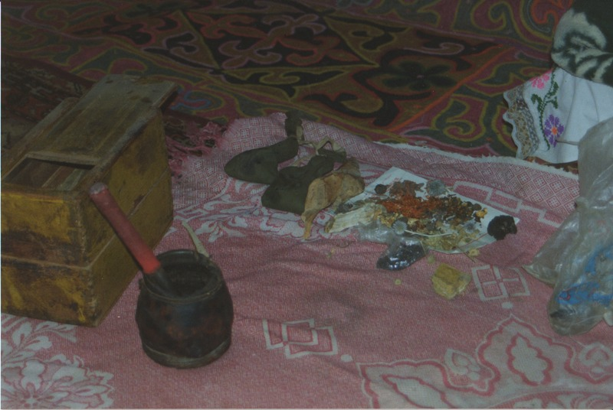

identifier
8c192f59-f74c-4d38-becf-705197157421

creator
Tsui Yen Hu

type
Image

coverage
Altai district
Handgate
PRC
Xinjiang

description
Dr. Marsel’s herbs and materia medica for making medicines

publisher

source
Scanned from colour print held in the archives of the University of Cambridge MacArthur Project "Environmental and Cultural Conservation in Inner Asia", Mongolia and Inner Asia Studies Unit.

rights

subject
medicine

date
1993-04-21

language

format
image/png

contributor

original filename
TsuiYenHu-Handgate-1993-30.png

relation

extent
1777x1191 px
3.3 MiB

