Photograph from Govisumber, No. 20
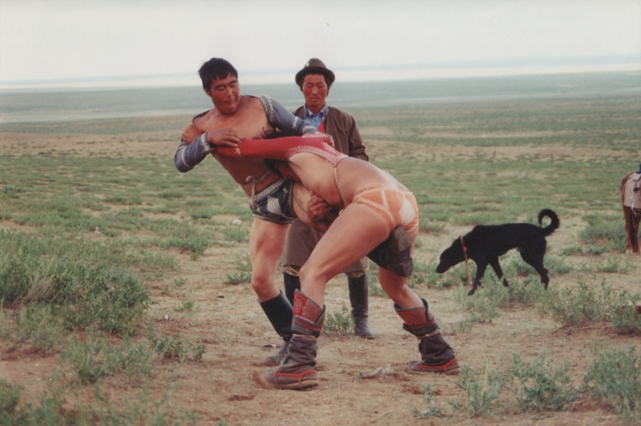

identifier
90c38ebd-1ba2-4247-9b03-d1626cb2fbe4

creator
Sneath, David

type
Image

coverage
Govisumber aimag
Mongolia

description

publisher

source
scanned from a photographic print held in the archives of the Mongolia and Inner Asia Studies Unit, University of Cambridge

rights

subject
wrestling

date
1995

language

format
image/png

contributor

original filename
sneath-govisumber_20.png

relation

extent
1776x1182 px
3.2MiB

